SQL INSERT INTO SELECT

🌟 Definition
# Source: AI Source: Provided by: [Data Path: Persons Table -> ID Column: 1, Name_En Column: Motasem Essam] -> From: [ChatGPT] on [6/11/2026]
SQL INSERT INTO SELECT is a statement used to copy data from one table and insert it into another existing table.
Unlike SELECT INTO, it does not create a new table. The destination table must already exist.

🎯 Purpose
# Source: AI Source: Provided by: [Data Path: Persons Table -> ID Column: 1, Name_En Column: Motasem Essam] -> From: [ChatGPT] on [6/11/2026]
INSERT INTO SELECT is commonly used to:
- Copy records between tables
- Create backups
- Archive old data
- Migrate data
- Merge data from multiple tables

🧠 Simple Example
# Source: AI Source: Provided by: [Data Path: Persons Table -> ID Column: 1, Name_En Column: Motasem Essam] -> From: [ChatGPT] on [6/11/2026]
Customers Table
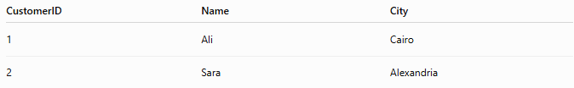
CustomerID | Name | City
1 | Ali | Cairo
2 | Sara | Alexandria

CustomersBackup Table
CustomerID | Name | City
(empty)

SQL Statement
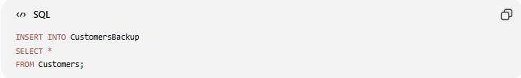
INSERT INTO CustomersBackup
SELECT *
FROM Customers;

Result
CustomersBackup
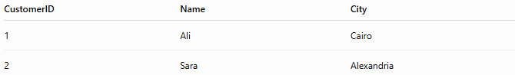
CustomerID | Name | City
1 | Ali | Cairo
2 | Sara | Alexandria
Data is copied into the existing table.

📝 Syntax
# Source: AI Source: Provided by: [Data Path: Persons Table -> ID Column: 1, Name_En Column: Motasem Essam] -> From: [ChatGPT] on [6/11/2026]
Copy All Columns
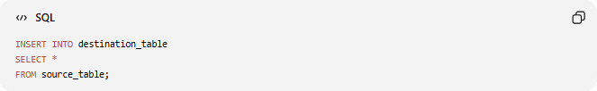
INSERT INTO destination_table
SELECT *
FROM source_table;

Copy Specific Columns
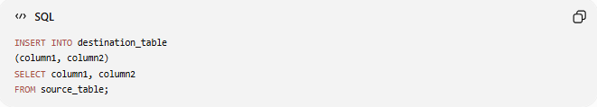
INSERT INTO destination_table
(column1, column2)
SELECT column1, column2
FROM source_table;

📚 Example 1: Copy Entire Table
# Source: AI Source: Provided by: [Data Path: Persons Table -> ID Column: 1, Name_En Column: Motasem Essam] -> From: [ChatGPT] on [6/11/2026]
Source Table
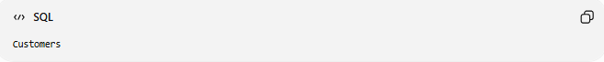
Customers

Destination Table
CustomersBackup

Query
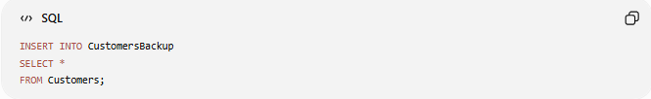
INSERT INTO CustomersBackup
SELECT *
FROM Customers;

Process
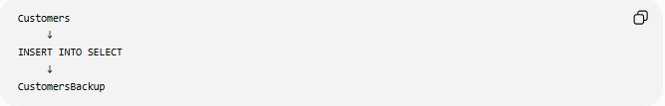
Customers
↓
INSERT INTO SELECT
↓
CustomersBackup

📚 Example 2: Copy Specific Columns
# Source: AI Source: Provided by: [Data Path: Persons Table -> ID Column: 1, Name_En Column: Motasem Essam] -> From: [ChatGPT] on [6/11/2026]
Query
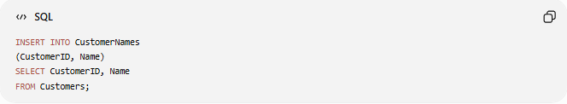
INSERT INTO CustomerNames
(CustomerID, Name)
SELECT CustomerID, Name
FROM Customers;

Result
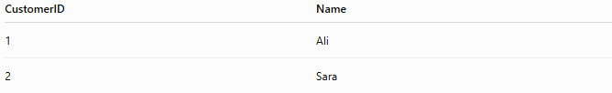
CustomerID | Name
1 | Ali
2 | Sara
Only selected columns are copied.

📚 Example 3: Copy Filtered Records
# Source: AI Source: Provided by: [Data Path: Persons Table -> ID Column: 1, Name_En Column: Motasem Essam] -> From: [ChatGPT] on [6/11/2026]
Query
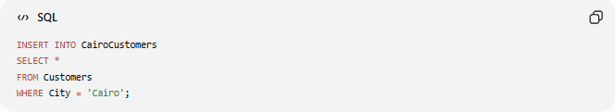
INSERT INTO CairoCustomers
SELECT *
FROM Customers
WHERE City = 'Cairo';

Source Table
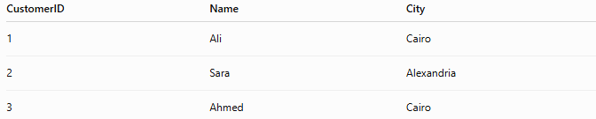
CustomerID | Name | City
1 | Ali | Cairo
2 | Sara | Alexandria
3 | Ahmed | Cairo

Result
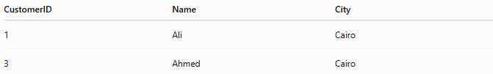
CustomerID | Name | City
1 | Ali | Cairo
3 | Ahmed | Cairo
Only matching rows are copied.

📚 Example 4: Copy Data from Another Database
# Source: AI Source: Provided by: [Data Path: Persons Table -> ID Column: 1, Name_En Column: Motasem Essam] -> From: [ChatGPT] on [6/11/2026]
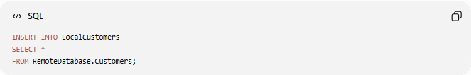
INSERT INTO LocalCustomers
SELECT *
FROM RemoteDatabase.Customers;

Useful for:
- Data migration
- Data synchronization
- Importing records

📚 Example 5: Insert Data from a JOIN
# Source: AI Source: Provided by: [Data Path: Persons Table -> ID Column: 1, Name_En Column: Motasem Essam] -> From: [ChatGPT] on [6/11/2026]
Query
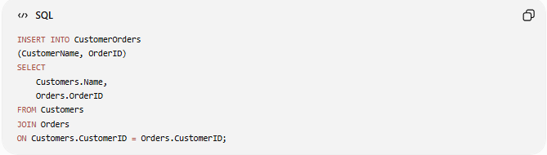
INSERT INTO CustomerOrders
(CustomerName, OrderID)
SELECT
Customers.Name,
Orders.OrderID
FROM Customers
JOIN Orders
ON Customers.CustomerID = Orders.CustomerID;

Result
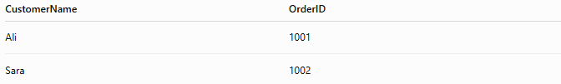
CustomerName | OrderID
Ali | 1001
Sara | 1002

⚠️ Column Rules
The number of columns must match.

Correct
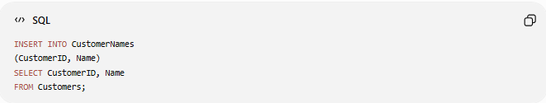
INSERT INTO CustomerNames
(CustomerID, Name)
SELECT CustomerID, Name
FROM Customers;

Incorrect
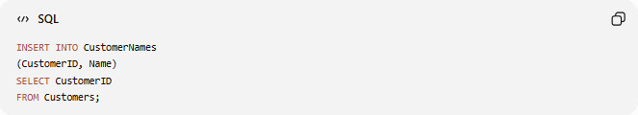
INSERT INTO CustomerNames
(CustomerID, Name)
SELECT CustomerID
FROM Customers;
Error because column counts differ.

🛠️ Complete Example

1️⃣ Create Source Table
# Source: AI Source: Provided by: [Data Path: Persons Table -> ID Column: 1, Name_En Column: Motasem Essam] -> From: [ChatGPT] on [6/11/2026]
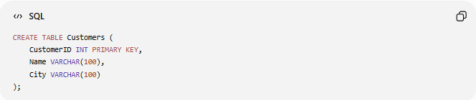
CREATE TABLE Customers (
CustomerID INT PRIMARY KEY,
Name VARCHAR(100),
City VARCHAR(100)
);

2️⃣ Insert Sample Data
# Source: AI Source: Provided by: [Data Path: Persons Table -> ID Column: 1, Name_En Column: Motasem Essam] -> From: [ChatGPT] on [6/11/2026]
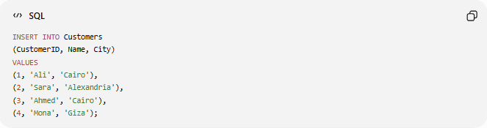
INSERT INTO Customers
(CustomerID, Name, City)
VALUES
(1, 'Ali', 'Cairo'),
(2, 'Sara', 'Alexandria'),
(3, 'Ahmed', 'Cairo'),
(4, 'Mona', 'Giza');

3️⃣ Create Destination Table
# Source: AI Source: Provided by: [Data Path: Persons Table -> ID Column: 1, Name_En Column: Motasem Essam] -> From: [ChatGPT] on [6/11/2026]
CREATE TABLE CustomersBackup (
CustomerID INT,
Name VARCHAR(100),
City VARCHAR(100)
);

4️⃣ Copy All Records
# Source: AI Source: Provided by: [Data Path: Persons Table -> ID Column: 1, Name_En Column: Motasem Essam] -> From: [ChatGPT] on [6/11/2026]
INSERT INTO CustomersBackup
SELECT *
FROM Customers;

Real Example

prepared commands

1️⃣ Create Source Table
# Source: ScreenShot Source: Provided by: [Persons Table -> ID Column: 1, Name_En Column: Motasem Essam] -> Tool: [Automation Table -> ID Column: 16, Name_En Column: Screen Capture] -> From [Operating System: Wampserver64 -> phpmyadmin] on [6/11/2026]
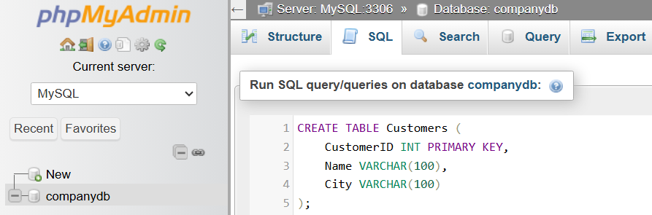
CREATE TABLE Customers (
CustomerID INT PRIMARY KEY,
Name VARCHAR(100),
City VARCHAR(100)
);
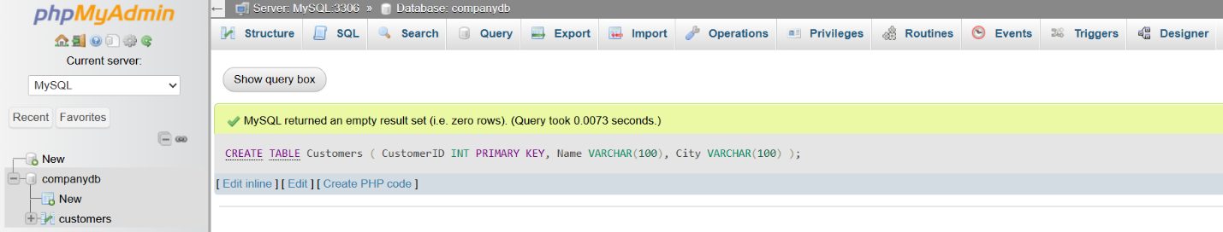

2️⃣ Insert Sample Data
# Source: ScreenShot Source: Provided by: [Persons Table -> ID Column: 1, Name_En Column: Motasem Essam] -> Tool: [Automation Table -> ID Column: 16, Name_En Column: Screen Capture] -> From [Operating System: Wampserver64 -> phpmyadmin] on [6/11/2026]
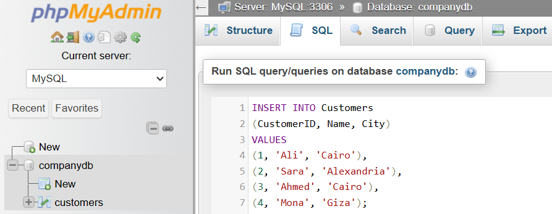
INSERT INTO Customers
(CustomerID, Name, City)
VALUES
(1, 'Ali', 'Cairo'),
(2, 'Sara', 'Alexandria'),
(3, 'Ahmed', 'Cairo'),
(4, 'Mona', 'Giza');
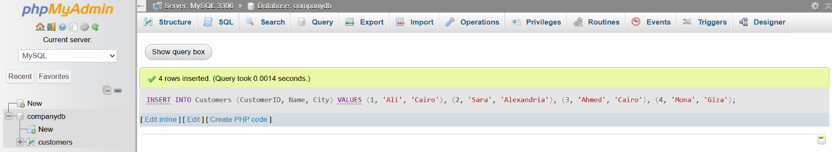
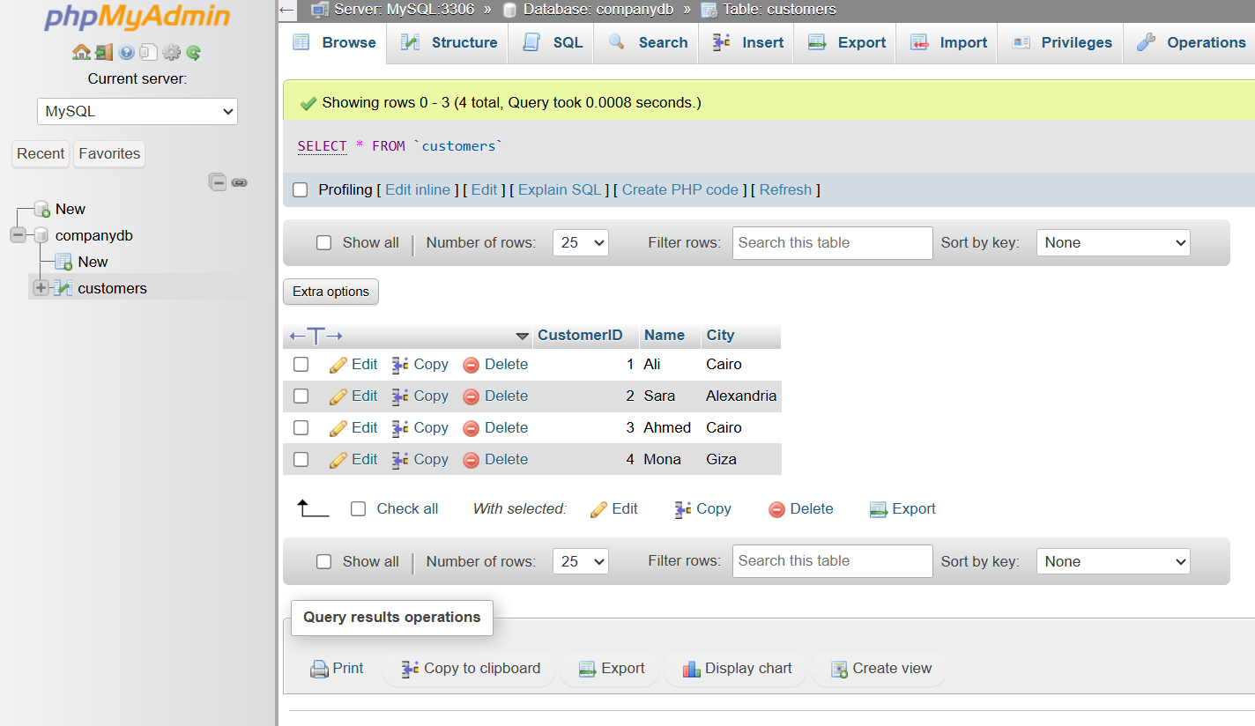

3️⃣ Create Destination Table
# Source: ScreenShot Source: Provided by: [Persons Table -> ID Column: 1, Name_En Column: Motasem Essam] -> Tool: [Automation Table -> ID Column: 16, Name_En Column: Screen Capture] -> From [Operating System: Wampserver64 -> phpmyadmin] on [6/11/2026]
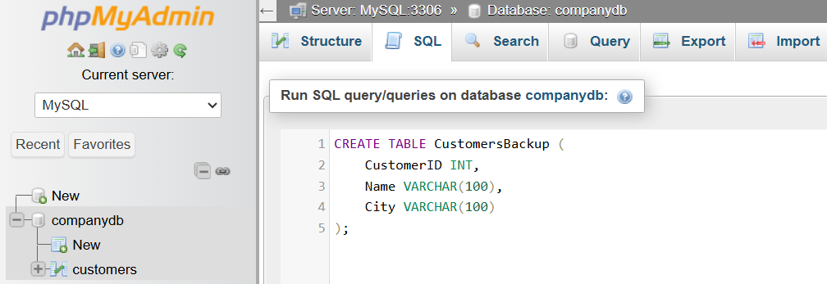
CREATE TABLE CustomersBackup (
CustomerID INT,
Name VARCHAR(100),
City VARCHAR(100)
);
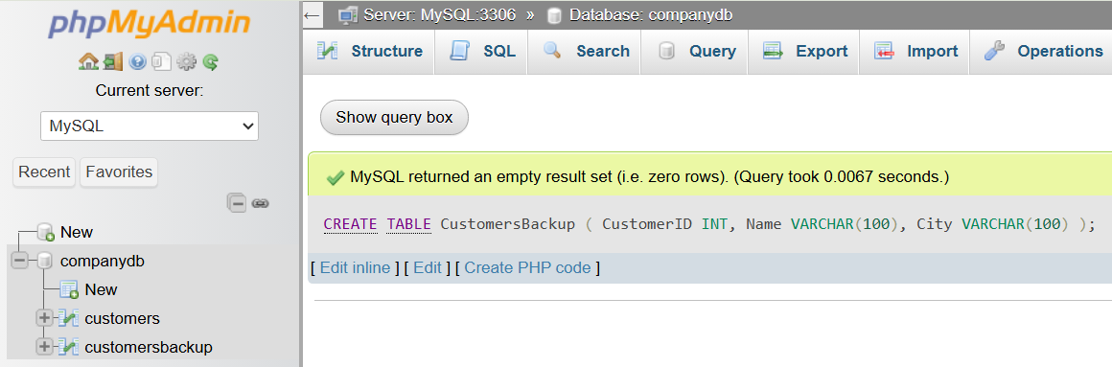

basic command

4️⃣ Copy All Records
# Source: ScreenShot Source: Provided by: [Persons Table -> ID Column: 1, Name_En Column: Motasem Essam] -> Tool: [Automation Table -> ID Column: 16, Name_En Column: Screen Capture] -> From [Operating System: Wampserver64 -> phpmyadmin] on [6/11/2026]
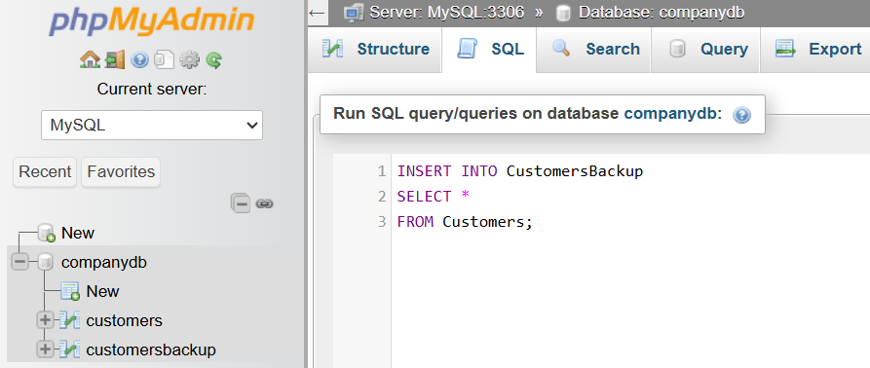
INSERT INTO CustomersBackup
SELECT *
FROM Customers;
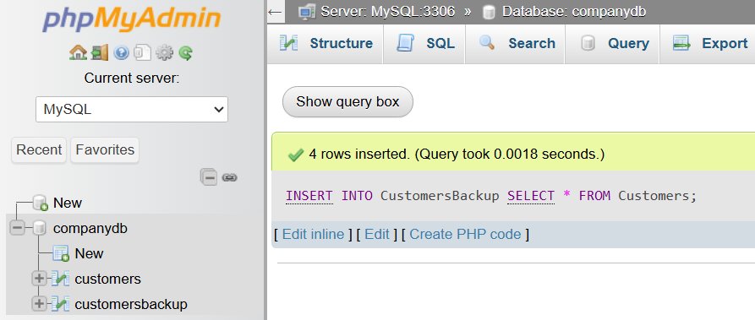
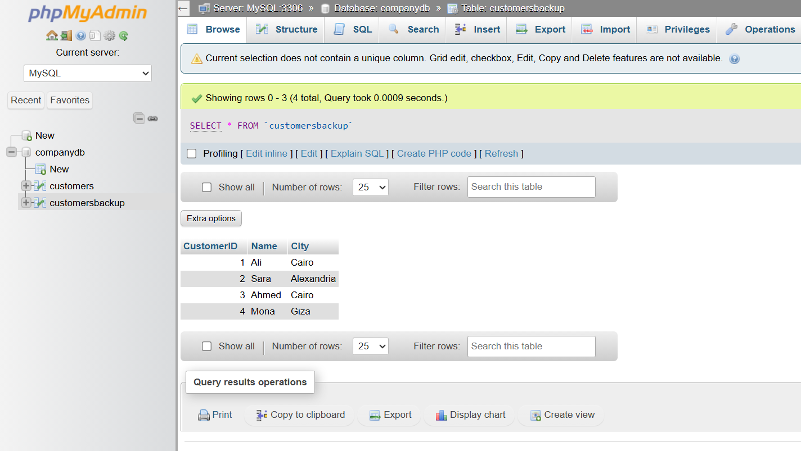

📊 Side-by-Side Comparison
# Source: AI Source: Provided by: [Data Path: Persons Table -> ID Column: 1, Name_En Column: Motasem Essam] -> From: [ChatGPT] on [6/11/2026]
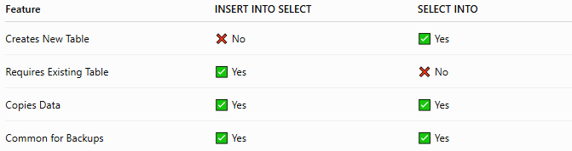
Feature | INSERT INTO SELECT | SELECT INTO
Creates New Table | ❌ No | ✅ Yes
Requires Existing Table | ✅ Yes | ❌ No
Copies Data | ✅ Yes | ✅ Yes
Common for Backups | ✅ Yes | ✅ Yes

INSERT INTO SELECT
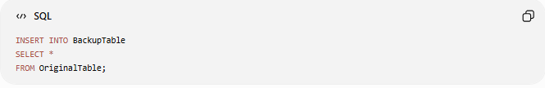
INSERT INTO BackupTable
SELECT *
FROM OriginalTable;
Uses an existing table.

SELECT INTO
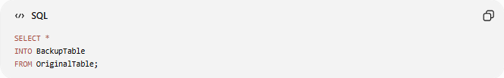
SELECT *
INTO BackupTable
FROM OriginalTable;
Creates a new table automatically.

🛠️ Common Use Cases
# Source: AI Source: Provided by: [Data Path: Persons Table -> ID Column: 1, Name_En Column: Motasem Essam] -> From: [ChatGPT] on [6/11/2026]
Backup Data
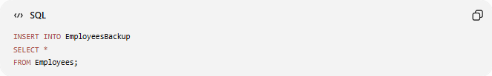
INSERT INTO EmployeesBackup
SELECT *
FROM Employees;

Archive Old Records
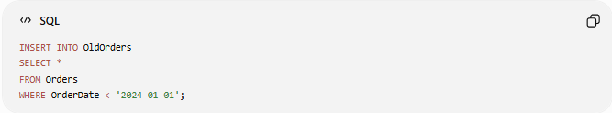
INSERT INTO OldOrders
SELECT *
FROM Orders
WHERE OrderDate < '2024-01-01';

Copy Active Users
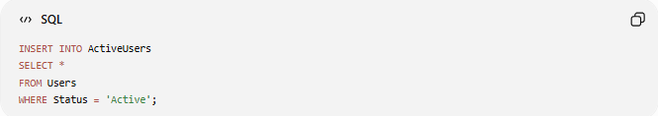
INSERT INTO ActiveUsers
SELECT *
FROM Users
WHERE Status = 'Active';

Data Migration
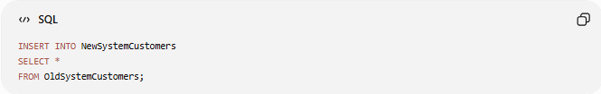
INSERT INTO NewSystemCustomers
SELECT *
FROM OldSystemCustomers;

🌍 Real-World Example
Employees Table
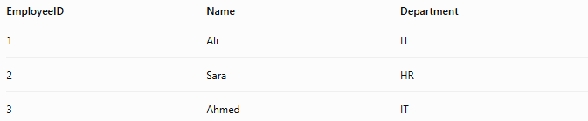
EmployeeID | Name | Department
1 | Ali | IT
2 | Sara | HR
3 | Ahmed | IT

Query
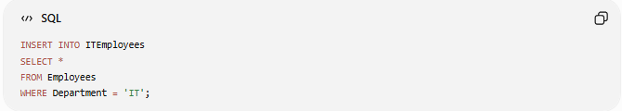
INSERT INTO ITEmployees
SELECT *
FROM Employees
WHERE Department = 'IT';

Result
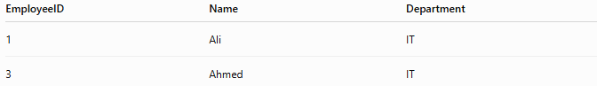
EmployeeID | Name | Department
1 | Ali | IT
3 | Ahmed | IT
Only IT employees are copied.

🔢 Process Flow
# Source: AI Source: Provided by: [Data Path: Persons Table -> ID Column: 1, Name_En Column: Motasem Essam] -> From: [ChatGPT] on [6/11/2026]
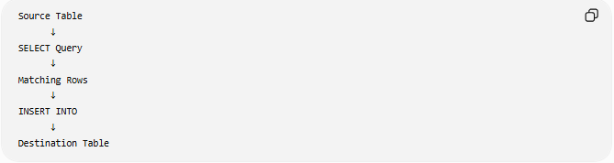
Source Table
↓
SELECT Query
↓
Matching Rows
↓
INSERT INTO
↓
Destination Table

⚖️ Side-by-Side Comparison
# Source: AI Source: Provided by: [Data Path: Persons Table -> ID Column: 1, Name_En Column: Motasem Essam] -> From: [ChatGPT] on [6/11/2026]
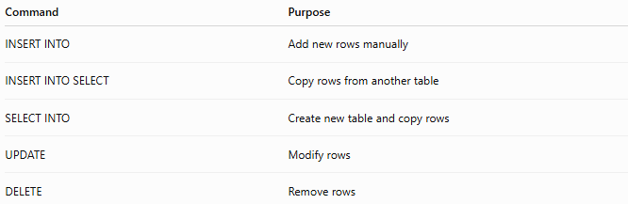
Command | Purpose
INSERT INTO | Add new rows manually
INSERT INTO SELECT | Copy rows from another table
SELECT INTO | Create new table and copy rows
UPDATE | Modify rows
DELETE | Remove rows

🧠 Simple Analogy
# Source: AI Source: Provided by: [Data Path: Persons Table -> ID Column: 1, Name_En Column: Motasem Essam] -> From: [ChatGPT] on [6/11/2026]
Imagine you have two filing cabinets:
Customers Cabinet
CustomersBackup Cabinet
INSERT INTO SELECT means:
Take documents from Cabinet A
and place copies into Cabinet B.
The destination cabinet already exists; you're simply adding copies of the records.

🧭 Summary
# Source: AI Source: Provided by: [Data Path: Persons Table -> ID Column: 1, Name_En Column: Motasem Essam] -> From: [ChatGPT] on [6/11/2026]
SQL INSERT INTO SELECT is used to copy data from one table and insert it into another existing table. It can copy all columns, specific columns, filtered records, or results from joined tables. Unlike SELECT INTO, it does not create a new table and requires the destination table to already exist. It is commonly used for backups, archiving, migrations, and data synchronization.

